**Nama : Alexander Agung Raya**

**Kelas/Absen : TI_2H/05**

**Nim : 2341720040**

UNIT 4

E-COMMERCE

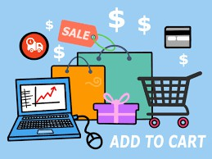

**Learning Outcomes:**

By the end of the lesson, the students are expected to be able to use appropriate English to:

* explain the definition of E-commerce.
* tell their experiences related to online shopping.
* explain types of online shopping.
* explain about online transaction.
* identify adverbs of quantity and differentiate their uses.
* understand and make sentences using *adverbs of quantity*.
* understand and make sentences using connector *and, but, or,* and *so*.
* read and understand the email about security issues.
* identify and explain safety issues on online transaction.



**4.1 Online Shopping and Transactions**

**Exercise 1**: Work in pairs. Explain about the definition of e-commerce. Is it the same as online shopping? Share it with the class.

Answer : e-commerce is electronic shopping that can be accessed anywhere such as tokopedia, shoppe eth.

**Exercise 2**: Tell about your experience while doing online shopping. What product or services do you usually buy online? What product do you not buy online? What are considerations you have before deciding to buy an item by online shopping? Do you have any bad experience buying an item online? What happened?

Answer : a bad experience is that the goods are sent late, before I buy the goods I check the reviews of the goods and then check whether this shop has an offlcial



**Exercise 3**: Listen to this interview with David Aston. He works for a company that sells home cleaning products. Mark the statement True (T) or False (F).

|  |  |
| --- | --- |
| 1. David’s company sells mainly online. | /F |
| 2. 70% of their business is online. | F / |
| 3. People buy their cleaning products when they buy their food. | T / |
| 4. People buy their cleaning product in supermarkets. | / T |
| 5. Online sales are growing. | F / |

**Exercise 4**: Read the following text about How to buy on the Internet and do the exercise.

**How to Buy on the Internet**

The first thing to do is to look for the product in a search engine, or even better, in a comparison engine or bargain finder, to find the lowest price.

Most online shop websites are designed so that customers follow these steps to do their **virtual shopping**.

You start by adding the items you want to buy to the **shopping basket**, or **virtual shopping trolley**. When you have selected the items that you want to buy, you proceed to the payment section by clicking on the **checkout button**.

You may have to **log in**, provide your username and password, or **sign up**, by providing your personal data, billing and shipping address, etc., if this is the first time you have accessed the site.

You will be given an account, so you are recognized as a customer. You will be asked to enter payment details, e.g. credit card numbers, etc. Before the transaction is completed you will be asked to confirm the order and check all the information is correct.

Finally, you **log out** and leave the website.

There are different types of electronic payment: credit cards or debit cards. A **digital wallet**, the electronic equivalent of a wallet for online shopping, hold credit card data, and passwords for logging into websites. PayPal, Microsoft’s Passport, and Yahoo! Wallet are examples of **digital wallets.**

*Taken from English Professional in Use ICT, pp. 64.*

What are the steps in buying products online? Number these sentences in the correct order.

1. The costumer opens an account.
2. The customer goes to the check-out.
3. The customer puts the item(s) in a shopping cart.
4. The customer pays for the product (s) with a credit or debit card.
5. The customer goes to the website.
6. The customer searches and/or browses the website.
7. The customer chooses the item(s) to buy.
8. The customer checks the order.

Answer :   
 **e.** The customer goes to the website.

**f.** The customer searches and/or browses the website.

**g.** The customer chooses the item(s) to buy.

**c.** The customer puts the item(s) in a shopping cart.

**b.** The customer goes to the check-out.

**a.** The customer opens an account.

**d.** The customer pays for the product(s) with a credit or debit card.

**h.** The customer checks the order.

**Exercise 5**: Read about the information about types of e-commerce and do the exercise.

**Types of E-commerce**

Companies whose activity is centered on the internet are called dotcoms, after their web addresses. However, most e-commerce business are bricks and clicks, as they have both physical and online presence.

Although there are some examples of **B2B commerce**, business to business, e-commerce is mainly used for **B2C**, **business to customer**, or even for **C2C**, **consumer to consumer**. Internet auctions websites like e-Bay where people offer products and sell them to the highest bidder, are an example of C2C e-commerce.

*Taken from English Professional in Use ICT, pp. 64.*

Match the type of business in the box to the correct column 1-4. Add another example of each type.

**B2C Business-to-Costumer**

**C2C Costumer-to-Customer**

**B2B Business-to-Business**

**M-commerce**

|  |  |  |  |  |
| --- | --- | --- | --- | --- |
| **Types of Business** | **1. B2B** | **2. B2C** | **3. C2C** | **4. M-commerce** |
| **Explanation** | Companies exchange information and make wholesale  transaction. | Companies sell products or sservices to customers over  the Internet. | People sell or exchange second-hand, used items or  collectibles. | Customers purchase products and services via  mobile devices. |
| **Examples** | Coffee supplier to Nestlé | Amazon | eBay | News, sport results |

**Exercise 6**: Shayan is telling Monika how customers will pay for something online on a new website. Complete this dialogue with the words in the box.

|  |  |  |  |
| --- | --- | --- | --- |
| **account** | **bank** | **completes** | **confirmation customer** |
| **first** | **gateway** | **payment** | **rejection web** |

|  |  |  |
| --- | --- | --- |
| Monika | : | Shayan, can you explain how a customer (1) completes an online transaction? |
| Shayan | : | OK, it’s very easy. (2) first, the customer will place an order. The seller’s  (3) web server will confirm availability of the product and send a response. After that, the customer checks out and completes the (4) payment instructions. Then the server will send a payment request to a payment (5) gateway. The payment gateway will check the buyer’s ability to pay with the (6) bank..  OK? |
| Monika | : | Fine. Go on. |
| Shayan | : | The bank will respond and send payment acceptance or (7) rejection to the  seller’s web server through the payment gateway. Finally, the customer will receive the server response with the order (8) confirmation or rejection. |
| Monika | : | Will the (9) customer have to register? |
| Shayan | : | Yes, all buyers must have their (10) account before they complete the  transaction. |
| Monika | : | Thank you. Now I understand. |

**Exercise 7**: Listen the recording about the above dialog. Check your answer.

**4.2. Online Shop Features**

**Exercise 8**: Work with your group. Examine the picture. Identify features of the website ([http://www.zalora.co](http://www.zalora.com/).id). Do you think it is a good e-commerce website? Why? Give your reasons.

Answer : Although I have never bought anything from Zalora, Zalora has managed to build its presence.

managed to build its presence. Also, the web UI looks nice and fancy and maybe the response is faster.

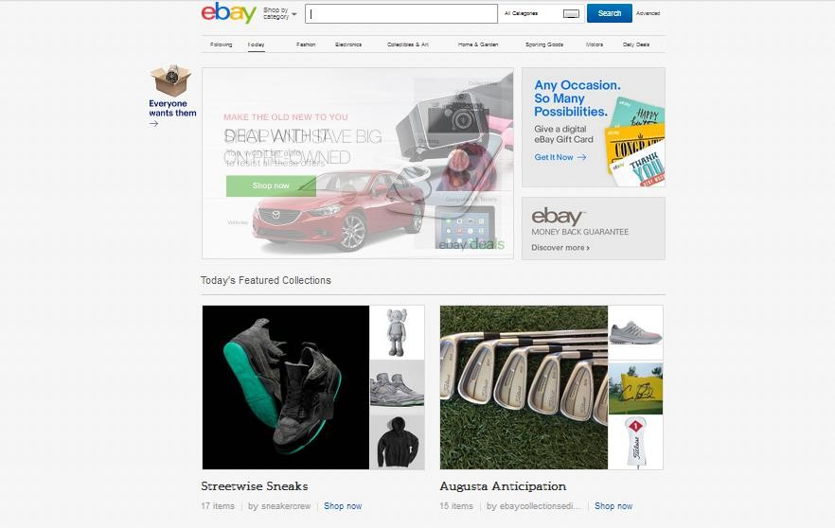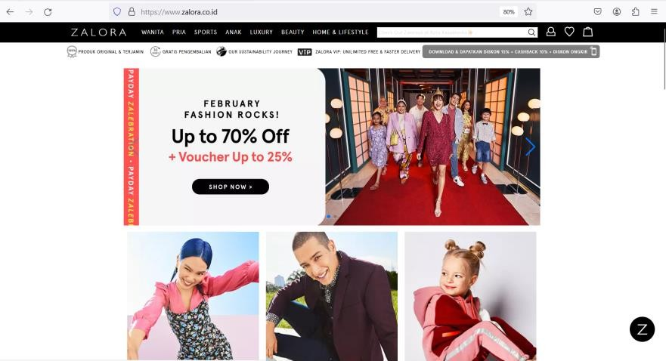

**Exercise 9**: Still work with the same group. Discuss an e-commerce website you know and like. Give reasons why you like it (its design, features, safety, etc).

Answer : I like Tokopedia. The UI is nice, it looks fancy but still gives a familiar impression.

for a wider demographic and easy to understand.

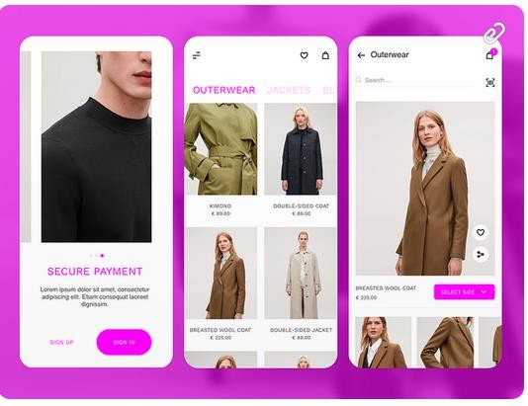

**4.3 Grammar Study**

**Exercise 10**: Pay attention to the following explanation of *Adverbs of Quantity*. Then, do the exercise following.

|  |  |
| --- | --- |
| **Talking about quantity** | |
| We use ***many*** and a ***few*** with  countable plural nouns. | We need a few users to test this.  They don’t have many customers. |
| We use ***much*** and a ***little*** with  uncountable nouns | We have a **little** money for online shopping each week.  I don’t have **much** knowledge on that subject. |
| We use **a lot of** and **some** with countable and uncountable  nouns. | **A lot of** business need E-commerce upgrades.  **Some** money has been kept aside for this |

# Choose the correct words to complete these sentences.

1. *A lot of/~~Much~~* shops have online presence. They offer *many/~~much~~* products online.
2. *Some ~~/A little~~* companies offer customer services an advice on their E- commerce websites.
3. I don’t have *much/~~many~~* knowledge of computers, but I can still shop online.
4. Companies spend *a lot of/~~many~~* money on E-commerce security.
5. Even when companies only have *~~a little~~/a* few money online marketing, they should spend it.

**Exercise 11**: Work in pairs. Use the words on the box (Exercise 13) to talk about your own online shopping habbit.

For example: *I buy a lot of clothes online rather than go to the local mall*.

Answer :

- I buy many clothes at once online to cut cost of shipment.

- I sell a lot of stuff so that I get much money.

- I buy just few items that I need.

- I use a little money for online shopping.

- I have some payment methods prepared for online shopping.

**Exercise 12**: Study the explanation in the box about how to *link ideas*. Then, do the exercise following.

|  |  |
| --- | --- |
| **Linking ideas** | |
| We use **and** to link sentences that describe similar actions or situations. | *I have a PC* ***and*** *a laptop at home.* |
| We use **but** to link sentences that describe different ideas/actions or situations. | *I use Amazon* ***but*** *I don’t use iTunes.* |
| We use **so** to say that something has happened as a result of something. | *She’s got a Kindle,* ***so*** *she doesn’t buy*  *many books now.* |
| We use **or** to link sentences that describe two possible actions or situations. | *Would you like tea* ***or*** *coffee?* |

Complete this text with the words in the box.

**and but or so**

Companies want to reach more customers, (1) so they go online. It is easy to set up online business (2) but it is difficult to design and develop a website that attracts a lot of customers. Hardware (3) and software provide basic infrastructure for E- commerce.

Networking, customer interface and payment solutions are very important parts of a

company’s E-commerce solution. Customers expect a fast and reliable service (4)

or they will go somewhere else to buy things.

*Taken from English for Information Technology 1, pp.39*

**Exercise 13**: Match the first half of the sentences (1-6) to the second half (a-f)

|  |  |
| --- | --- |
| 1. Effective product information and 2. Customers can use their credit cards, PayPal, or 3. We used a lot of promotions, so 4. I don’t know how to buy online but, 5. They want to buy a Cat 5e cable, so 6. In e-commerce you can look at a picture of a product, but | 1. I’ll check online tutorials 2. electronic cheques to pay for transactions 3. you can’t touch it. 4. our sales improved a lot. 5. they search the internet. 6. promotions attract customers |
| Answer  1-d  2-b  3-f  4-a  5-e  6-c |  |

**4.4. Online Transaction Security**

**Exercise 14**: Read this email then answer the following questions.

**To**: All employees

**From**: IT Director

**Subject**: Online transactions security

We are developing new website security features. We will have a virtual private network with a firewall which will help stop cyber-attacks on the network perimeter. The web application protection firewall (WAF) will protect our website from hacker attacks on customer contacts and login boxes. Secure Socket Layer (SSL) will create a secure connection for the users. We will have two-factor authentication (2FA). Website administrators will go through two layers of security before they access the hosting environment. This will prevent password leaks. All data will have encrypted backup to protect sensitive information.

I am sure the company will benefit from the new security measures. Thanks,

Hamda Banna

*Taken from English for Information Technology 1, pp.40*

1. What is the email about?
2. Who is Mr. Banna?
3. How many security features will the company have?
4. Which security feature will stop attacks on the company network?
5. What solution will protect customer contacts and login boxes?
6. What will protect private user information sent over the network?
7. What will the factor authentication protect?
8. What will protect information?

**Exercise 15**: Read the text about Online Security and do the exercises.

**Online Security**

Most online banks have introduced the concept of two-factor **authentication**, the simultaneous use of at least two different devices or layers of security to prevent fraud.

When you open an Internet account, you are given a confidential **PIN**, **Personal Identification Number**, and a password and username.

For some transactions, customers are required to use a **TAN**, **Transaction Authorization Number**, from a list provided by the bank. It can only be used once, and it acts as a second password.

**Security tokens** are microchip-based devices that generate a number that has to be typed by the user or read like a credit card. They are becoming a common form of two-factor authentication.

One of the best methods of identifying the user a bank account is **biometric authentication**, the use of physical trait, such as a fingerprint, to allow a person to log in. Some laptops have built in fingerprint readers, which makes online banking easier and more secure.

*Taken from English Professional in Use ICT, pp. 64.*

Complete this text with words from the text above.

Most financial institutions offering Internet-based products should use (1) authentication to reduce the risks of account fraud and identity theft.

At present, most authentication methodologies involve three basic factors:

* Something the user knows, for example a (2), the confidential number given by the institution.
* Something the user has, for example a (3), the keyring-like identification number generator.
* Something that shows who the user is, that is (4), for example a fingerprint.

Authentication methods that depend on more than one factor are more reliable; for example, the use of a (5), a TAN (something the user knows) to log in, and then a token (something that user has) to transfer funds.

*Adapted from Federal Institutions Examination Council.*